**Project Description:**

StyLEst is a cutting-edge app designed to provide a seamless and stylish online shopping experience, focusing on fashion and beauty products. Combining "Style" with "LEst" (implying "Lifestyle & Elegance" or "Best"), StyLEst aims to offer users a curated selection of elegant products, comprehensive details, and personalized recommendations. The app is user-friendly, allowing anyone to easily create an account, browse through a diverse range of items, and make purchases with a simple checkout process. Additionally, StyLEst fosters a vibrant community for fashion inspiration, making it the go-to platform for anyone looking to enhance their style and elegance effortlessly.

**Requirements Summary:**

| **MINIMUM REQUIREMENTS** | Processor Cores | Dual Core |
| --- | --- | --- |
| OS | Android 7.0, iOs 11.0 |
| RAM | 2 GB |
| **RECOMMENDED REQUIREMENTS** | Processor Cores | Quad Core or Higher |
| OS | Android 9.0 (Pie), iOs 14.0 |
| RAM | 4 GB or Higher |
| **OTHER REQUIREMENTS** | Permissions | Notifications, Storage, Location, and Camera |

Table 1. System Requirements

These specifications guarantee that the application will function flawlessly on a range of hardware configurations and offer all the functionality needed for a shopping experience while respecting security and user privacy policies.

**Prototype Description:**

The Prototype was created with the use of Canva. This is because Canva is an interactive Prototyping Software/Website that can easily be distributed to testers with the use of links sent by the developers.

**StyLEst Canva Link**:

https://www.canva.com/design/DAGGID6vi5c/cPAczEe3FiUi6zqUs6DK_w/edit

**User Scenario:**

Alex and Sam have been struggling to find stylish clothes online. This has made it difficult for them to stay fashionable and keep up with trends. They often miss out on new styles and good deals, which adds to their frustration. One day, Sam discovered an app called StyLEst, recommended by a friend who loves shopping. Sam tried it and found it easy to use with a great selection of trendy clothes. Sam quickly shared this find with Alex, hoping it would make shopping for clothes online easier and more enjoyable for both of them.

**StyLEst Mock-up/Prototype**:

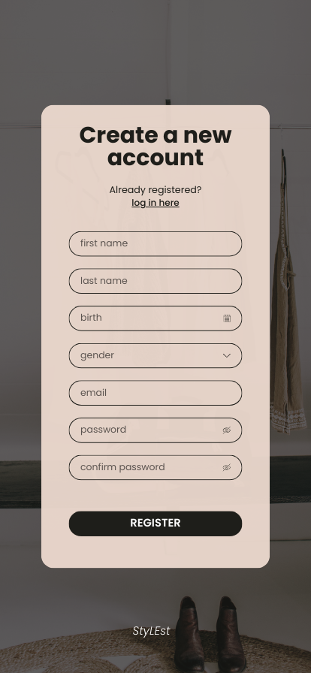

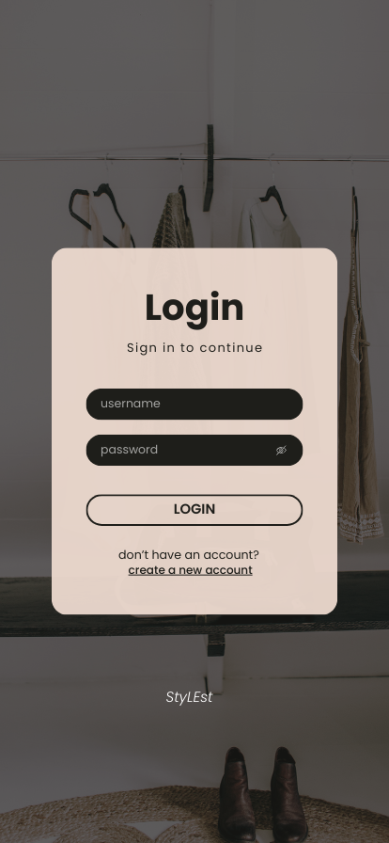

**Prototype on Phone**

This is how the prototype will look on a smaller phone.

**Prototype Flow**:

Main Screen:

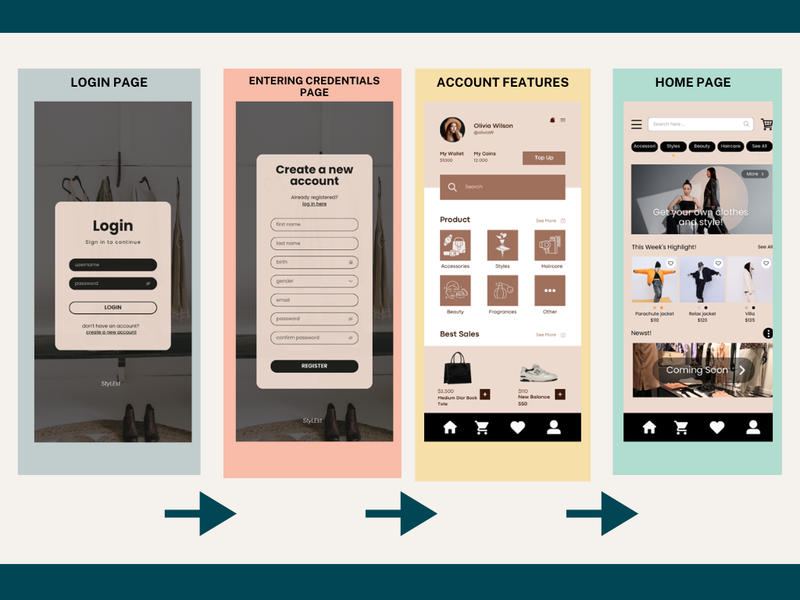

Figure 2. Login Prototype

Figure 2 shows how the user can Login and create a new account for the application.

Product Overview: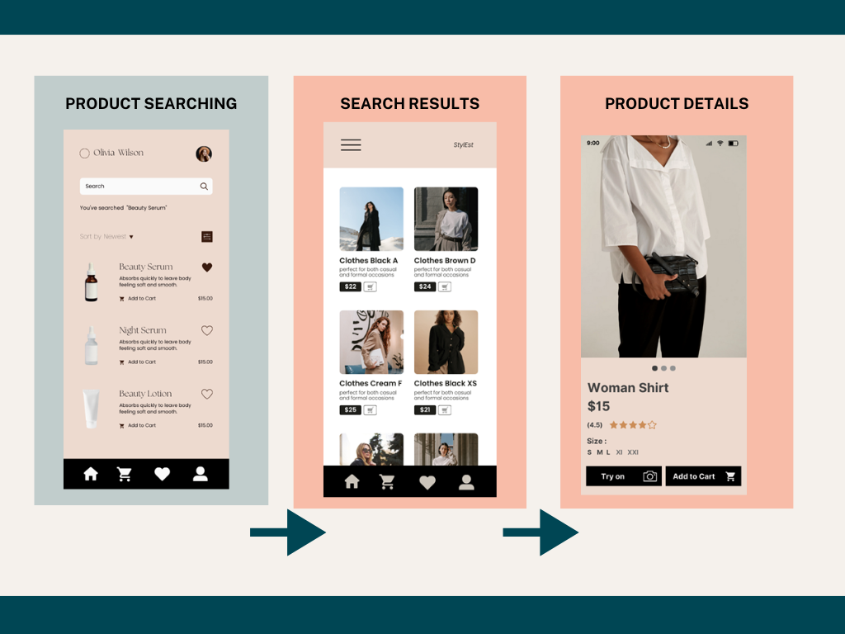

Figure 3.1. Renaming File/Folder

Figure 3.1 Shows that clicking the “pen” icon, the user will easily be able to

edit the application. This is similar for all Folders/Files.

Figure 3.2 Deleting Files/Folders

Figure 3.2 shows how the user can delete a file/folder. This can be accessed by holding down the folders or from the dropdown-edit. This will be like other files or folders.

Figure 3. Product Searching

Figure 3. shows the user high-resolution images and clear, concise product descriptions for an enhanced user experience.

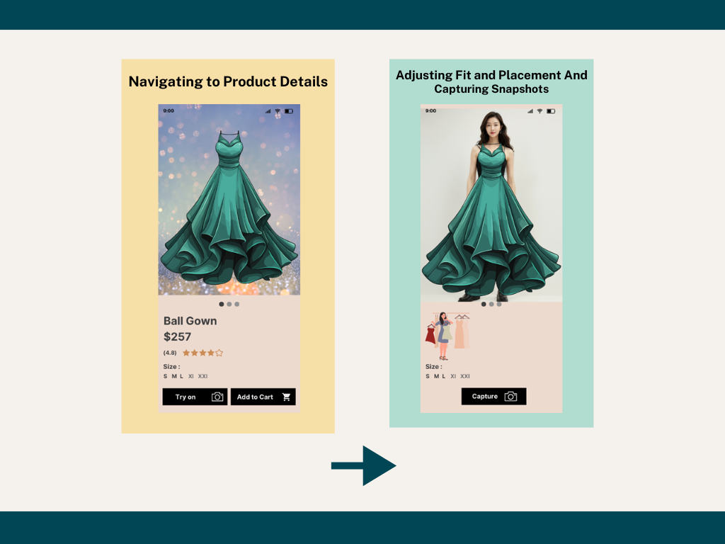

Figure 3.1. Virtual Try-on

Figure 3.1 shows the virtual try-on interface is responsive, offering smooth adjustments and realistic simulations of clothing items.

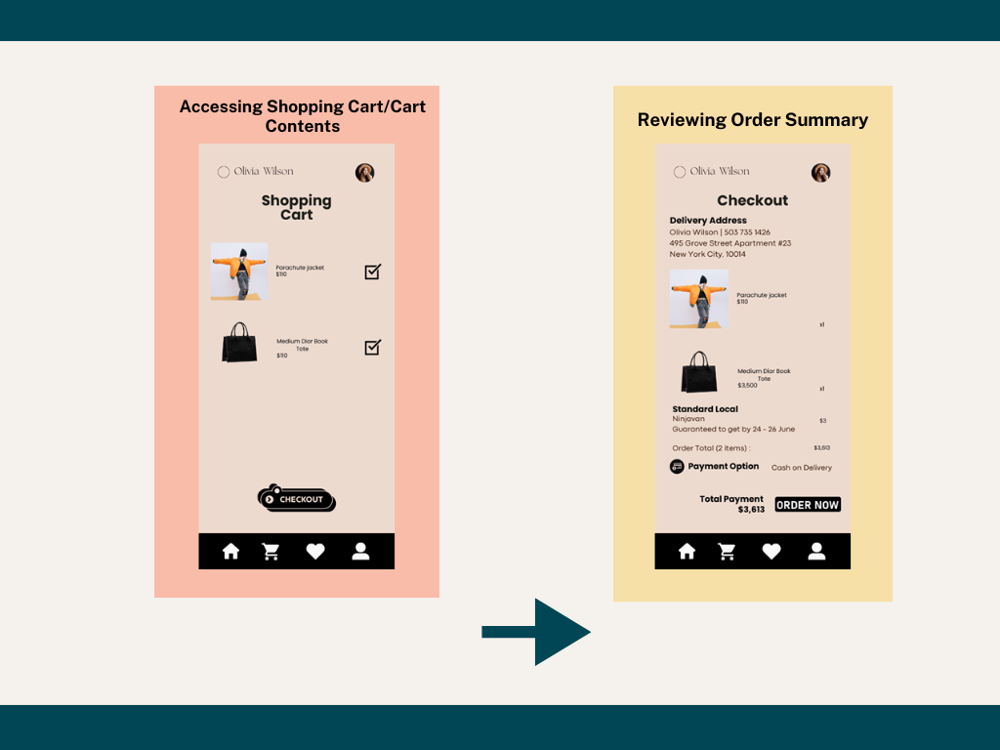

Figure 4. Checking out items

Figure 4. shows the checkout flow is streamlined with minimal steps and clear navigation.

**Rationale:**

The team has chosen to use Canva for creating the prototype, as it provides a user-friendly platform accessible to all team members for collaborative editing. Canva allows easy showcasing of the final application design upon completion. Moreover, it facilitates seamless presentation and sharing of prototypes with remote users, enabling quick edits based on received feedback. However, Canva also has limitations, such as requiring internet access for saving edits, which can hinder usability in offline scenarios. Additionally, when used on larger screens, smaller interface elements might be challenging to interact with effectively.

**Changes to the Requirements:**

The existing system requirements for StyLEst remain the same. However, we've clarified the usability goals for the prototype. We want it to be easy for users to navigate and use. We're focusing on making sure the app is straightforward and intuitive to use, following basic principles like keeping things simple and consistent. Due to time limits, we won't include online features right now. This means we won't be testing or focusing on those parts of the app. Our main aim is to create a prototype that's easy for users to understand and use smoothly when the full StyLEst app is ready.

**Initial Evaluation Plan:**

Given our current setup and preference for direct interaction, we've chosen to conduct face-to-face evaluations for the StyLEst prototype. This approach allows us to observe firsthand how users interact with the app and gather immediate feedback. We'll define clear usability criteria to guide our evaluation process, focusing on aspects like navigation ease and user interface intuitiveness. Additionally, we'll incorporate heuristic evaluation techniques based on established usability principles. After users interact with the prototype, we'll gather their feedback to ensure it meets their expectations and usability standards effectively.

# Usability Specifications

The prototype for StyLEst, a fashion and beauty app, aims to achieve the following usability measures:

* Effectiveness: This will assess how well the prototype performs essential tasks like browsing products, making purchases, and managing user accounts.
* Efficiency: This measure evaluates how easily and quickly users can accomplish tasks within the prototype.
* Utility: It ensures that the prototype supports necessary functions and provides suitable alternatives for different tasks related to shopping and personalization.
* Learnability: This measure focuses on how easily users can understand and navigate the prototype, assessing its intuitiveness and user-friendliness.
* Memorability: This evaluates how easily users can remember steps and interactions with the prototype, making it simpler for them to use the system repeatedly.

.

**Population**

Around 10-20 selected colleges from Section A124 will be using the StyLEst prototype. They will be tasked with specific actions outlined for the prototype, such as adding items to the cart. The success criteria for the prototype will be based on how well it performs these tasks as required.

**Prototype Tasks**

Three components comprise the tasks for the StyLEst app prototype evaluation: Main Navigation Tasks, Product Browsing Tasks, and Checkout Tasks. The following are some tasks that participants will complete to show off the functioning of the prototype:

* Utilize the main menu to navigate between the app's various parts.
* To find particular products, look through the product categories and filter choices.
* Put things in your shopping basket and check out.
* Change how many things are in the trolley.
* When checking out, provide your payment and shipping details.

These tasks were chosen to evaluate how easy it was to navigate, how well it worked for browsing and product selection, and how well it worked for completing purchases on the prototype. In order to give users a smooth and pleasurable shopping experience, several precautions were taken into consideration when designing the prototype.

Roles

The team will gather at the very least 10 participants when conducting this evaluation. With this in mind, the team will split the population and have similar roles in this evaluation.

| **Developer / UI Designer Member** | **Task(s)** |
| --- | --- |
| Anne Klein F. Amoroso | Will be recording time users interact with a task section, taking notes of the user’s experience, and relay the task that the participant will do. |
| Marchelle D. Atienza | Will be recording time users interact with a task section, taking notes of the user’s experience, and relay the task that the participant will do. |
| Ansharlene Crystal C. Balagosa | Will be recording time users interact with a task section, taking notes of the user’s experience, and relay the task that the participant will do. |

Table 2. Team Member Tasks

| Main Menu | Within 1 minute or Below | Highly Acceptable | Successful |
| --- | --- | --- | --- |
| Above 1 minute | Not Acceptable | Unsuccessful |
| Folders | Within 5 minutes or Below | Highly Acceptable | Successful |
| Above 5 minutes | Not Acceptable | Unsuccessful |
| Quiz | Within 5 minutes or Below | Highly Acceptable | Successful |
| Above 5 minutes | Not Acceptable | Unsuccessful |

Table 3. Time Interpretation

Table 3 represents the interpretation above represents how the team will be interpreting the time spent with each participant in their tasks. The table will be used as a guideline to interpret if the design of a given task is successful or not at a given task.

# Heuristic Evaluation

Evaluation of StyLEst will also use the 10 Usability Heuristic method of Evaluation.

*Visibility of System Status*

StyLEst keeps users informed about their shopping journey, from browsing to checkout. Progress indicators show where users are in the process, such as search results loading or order confirmation.

## Match Between System and Real World

The app uses familiar language and terms related to fashion and beauty. It avoids technical jargon and presents products and categories in a way that aligns with users' expectations in the fashion industry.

## User control and Freedom

The Prototype offers to deal with mistakes provided clearly marked “Emergency Exit”. To leave the unwanted state without going through an extended dialogue. Support undo and redo.

## Consistency and Standards

Users encounter consistent design elements, terminology, and interactions across StyLEst. Buttons, icons, and navigation are predictable, enhancing usability and reducing confusion.

## Error Prevention

## Error messages in StyLEst are proactive, aiming to prevent mistakes during the shopping process. For example, clear notifications are provided if an item is out of stock before adding to the cart.

.

## Recognition rather than recall

## Products, actions, and options in StyLEst are visible and self-explanatory. Users do not need to remember previous steps when navigating the app. Instructions and help options are readily accessible.

.

## Flexibility and Efficiency of Use

## StyLEst caters to both casual shoppers and fashion enthusiasts. It offers personalized recommendations based on browsing history and allows quick access to favorite items or categories.

## Aesthetic and Minimalist Design

## The app maintains a sleek and elegant design, focusing on showcasing products effectively. Unnecessary clutter is avoided, ensuring that each product and feature stands out prominently.

## Help Users Recognize, Diagnose, and Recover from Errors

## The app maintains a sleek and elegant design, focusing on showcasing products effectively. Unnecessary clutter is avoided, ensuring that each product and feature stands out prominently.

## Help and Documentation

## Users can easily find help resources within StyLEst. FAQs, tutorials, and customer support contact options are readily accessible, ensuring users can get assistance whenever needed during their shopping experience.

# Participant Survey and Feedback

**After conducting the online test,**

| **DATA GATHERING METHOD** | **DESCRIPTION** |
| --- | --- |
| Survey (Quantitative) | After the Online Testing, the team will be handing out a survey to the participants to gather data for the user’s experience with the prototype which the team will be interpreting in a 5-point Likert scale (**Refer to Table 5**. **5-Point Likert Scale Interpretation**). |
| Feedback (Qualitative) | The survey that the team provided will support a Feedback section to help users/participants speak out concerns or issues with the prototype that needs to be addressed. |

Table 2. Data Gathering Methods

The table above showcases the three (3) different data gathering methods the team will be using while conducting the online test of the StyLEst Prototype.

| **Question** | **Method of Answer** |
| --- | --- |
| **Section 1** | |
| Participant Number | Short Answer |
| On a scale of 1 to 5 how would you rate your experience with the StyLEst Prototype | 5-Point Scale |
| On a scale of 1 to 5 how was the UI design of the prototype |
| How easily were you able to follow the tasks provided |
| **Section 2: Features of the Prototype** | |
| User Account Management | 5-Point Scale |
| Product Discovery and Navigation |
| Product Details and Shopping Experience |
| Shopping Cart and Checkout |
| Virtual Try-On Interface |
| Adjusting Fit and Appearance |
| Capturing and Reviewing |
| User Experience Considerations |
| **Section 3: Feedback Section** | |
| Your Feedback | Short Answer |

Table 4. Survey Questionnaire

The table above presents the Questions that will be present in the survey for this Prototype. This survey will be handed to Participants after the Test using links. The Survey can still be viewed through this link

https://docs.google.com/forms/d/e/1FAIpQLScftzD20ZvUH3PZAj_yx1hU8Kg6n5wnvx3xrikBgLovGnSj5g/viewform?usp=sf_link .

| **Task** | **Time to Accomplish Tasks** | | **Interpretation** | **Classification** |
| --- | --- | --- | --- | --- |
|  |  | | |  |
| **Scale** | **Range Value** | **Interpretation** | | **Classification** |
| 5 | 4.50-5.00 | Highly Acceptable | | Successful |
| 4 | 3.50-4.49 | Acceptable | |  |
| 3 | 2.50-3.49 | Moderately Acceptable | | Neutral |
| 2 | 1.50-2.49 | Fairly Acceptable | | Unsuccessful |
| 1 | 1.00-1.49 | Not Acceptable | |  |

Table 5. 5-Point Likert Scale Survey Interpretation

Table 5 represents the Interpretation of the survey questions given to the participants. The survey will be used to interpret whether the design and features presented are successful and useful for students who suffer from pacing issues.